**QAT Testing and gNB Stack Compilation Guide**

**Compilation of gNB Stack**

**Ensure the following compilation flags are set for PDCP and QAT support:**

**make.inc**

**# For Qat Enable**  
-DPDCP_ASYNC_INTERFACE \

-DDPDK_QAT_INT \

-DPDCP_DPDK_SEC_INTERFACE \

# For Dpdk Enable

-DDPDK_22_11 \

**.gnb_settings**

**# For Qat Enable**

export PDCP_DPDK_ENABLED=1

export QAT_ENABLED=1

# For DPDK enable

export DPDK_ENABLED=1

export DPDK_SOCKET_ENABLED=1

**compile you stack   
./build.sh clean all; ./build.sh all tdd**

**Step-by-Step Procedure**

**Step 1: Check if the QAT Card is Inserted Properly**

1. **Verify QAT Co-processor via PCI:** Run the following command to check for the QAT card:

lspci | grep -i co-processor****



**Step 2: Create Virtual Functions (VF) for QAT & Bind PCI**

#!/bin/bash

echo 0 > /sys/bus/pci/drivers/c6xx/0000:45:00.0/sriov_numvfs

echo 16 > /sys/bus/pci/drivers/c6xx/0000:45:00.0/sriov_numvfs

wait

echo 0 > /sys/bus/pci/drivers/c6xx/0000:46:00.0/sriov_numvfs

echo 16 > /sys/bus/pci/drivers/c6xx/0000:46:00.0/sriov_numvfs

wait

echo 0 > /sys/bus/pci/drivers/c6xx/0000:47:00.0/sriov_numvfs

echo 16 > /sys/bus/pci/drivers/c6xx/0000:47:00.0/sriov_numvfs

wait

echo "Vf created for QAT use"  
  
after creating VF you can find vf pci  
 lspci | grep -i co-processor  
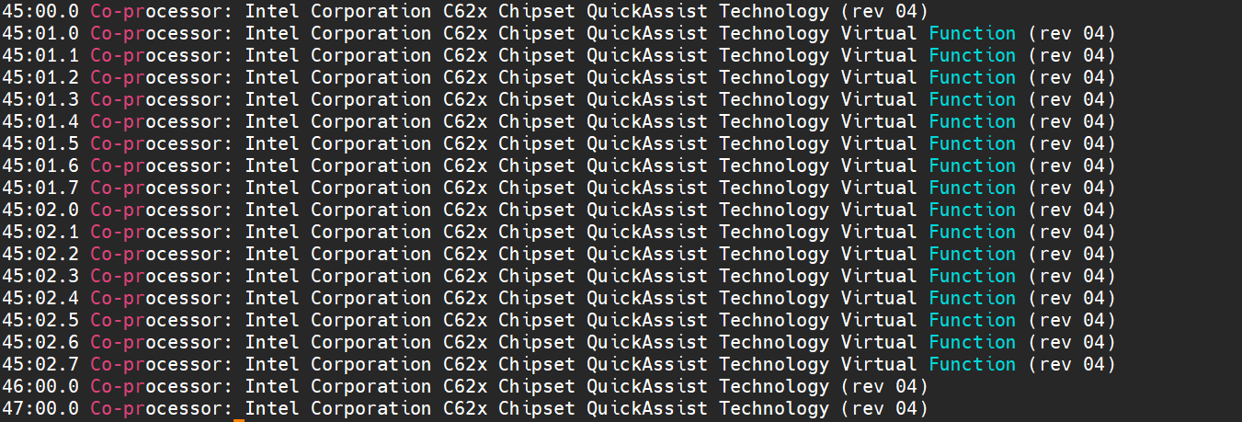

**L1 Cfg Changes**

**dpdk.sh**

enter four QAT vf pci

Phycfg_xran.xml

**gNB changes**

execute_pdcp.sh  


**Ciphering and Integrity Settings**

**Enable Ciphering and Integrity**

1. **Ciphering:**
   * 0 = Disable
   * 1 = Enable

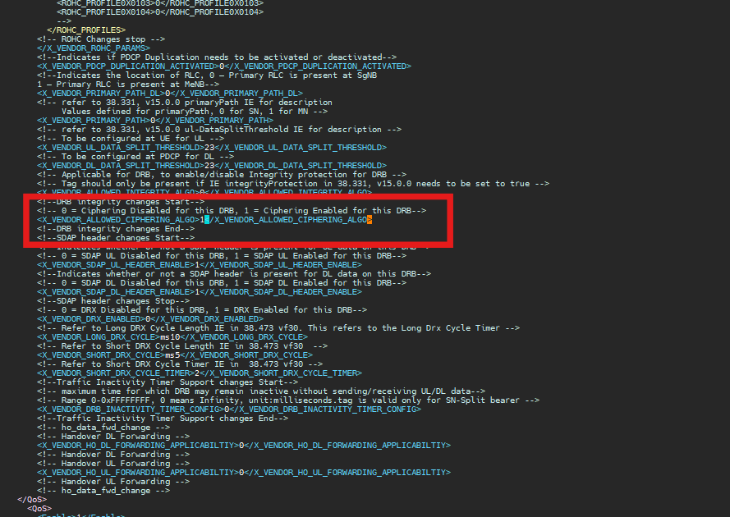

1. **Integrity:**
   * 0 = Disable
   * 1 = Enable

|  |  |  |  |
| --- | --- | --- | --- |
|  |  |  |  |
| **Ciphering** | **Integrity** | **l1 side changes** | |
|  |  | **<ciphAlgo>** | **<intAlgo>** |
| NEA2 | NIA2 | 6 | 3 |
| NEA2 | NIA1 | 6 | 19 |
| NEA1 | NIA1 | 12 | 19 |
| NEA1 | NIA2 | 12 | 3 |
| NEA0 | NIA1 | 1 | 1 |
| NEA0 | NIA2 | 1 | 1 |

**FOR NEA2-NIA2**

phycfg_xran.xml

**TR196_gNodeB_CU_Data_Model.xml**

**FOR NEA2-NIA1**

**phycfg_xran.xml**

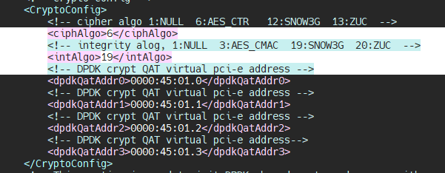

**TR196_gNodeB_CU_Data_Model.xml**

**FOR NEA1-NIA1**

**phycfg_xran.xml**

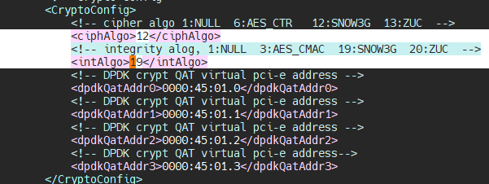

**TR196_gNodeB_CU_Data_Model.xml**

**FOR NEA1-NIA2**

**phycfg_xran.xml**

**

**FOR NEA0-NIA1**

**phycfg_xran.xml**

**TR196_gNodeB_CU_Data_Model.xml**

For this case disable ciphering and integrity

**FOR NEA0-NIA2**

**phycfg_xran.xml**

**TR196_gNodeB_CU_Data_Model.xml**

For this case disable ciphering and integrity

